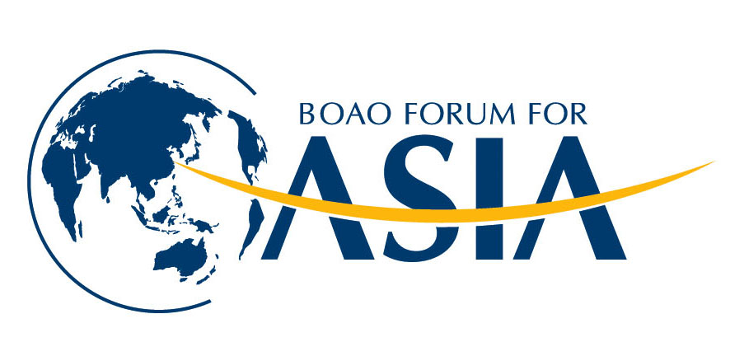
记者采访申请表
Interview Request Form

此表供参加博鳌亚洲论坛2018年会的记者申请采访使用。在您会前向秘书处(interview@boaoforum.org)或年会期间向大会新闻中心提交此表后，新闻中心工作人员将尽可能安排您与被采访人的采访。如您的申请得以安排，我们将根据您所留下的联系办法与您联系。每一家媒体限10名采访对象。 每位采访对象填写一张表格。

This Application Form is for the use by participating reporters of Boao Forum for Asia Annual Conference 2018. Upon receiving your application before the BFA AC2018 to interview@boaoforum.org or during the events to the press center, we will try to arrange the interviews of the prospective interviewees. The arrangement of such interviews will be notified to you according to the contact information specified in this form. Each media is limited to ten interviewees. Please submit one interview request form for each interviewee.
记者姓名  Reporter’s Name: | 媒体机构  Media Organization:
手机  Mobile | 邮箱  Email
采访形式 （书面采访/面对面采访）
Interview Format (Paper Interview/Face-to-Face interview)
拟采访对象 Interviewee

问题Questions
媒体简介 Brief Introduction of Media Organization

